OUR LADY OF PROMPT SUCCOR
CATHOLIC CHURCH
Church Address: 2120 Elliott Street, Alexandria, LA Website Address: TUwww.olpschurch.orgUT
Mailing Address: 401 21st Street, Alexandria, LA 71301 Tel: (318) 445-3693 Fax (318) 445-8471

MARCH 31, 2024 EASTER SUNDAY -- THE RESURECTION OF THE LORD Vol. XIII No. 18

HAPPY EASTER! May the life and peace of the Risen Lord Jesus Christ shine upon you and your loved ones today and throughout the year! The clergy and staff of Our Lady of Prompt Succor Church and School wish you all God’s blessings in this hope-filled season.

THANK YOU to everyone who worked to make our Lent, Holy Week and Easter Sunday celebrations so prayerful and beautiful. You did a great job, as always! Thanks to our altar servers and ministers of the liturgies; our choirs, musicians and cantors; the Altar Society and its helpers who decorated the church; and everyone who assisted. – Fr. Rusty

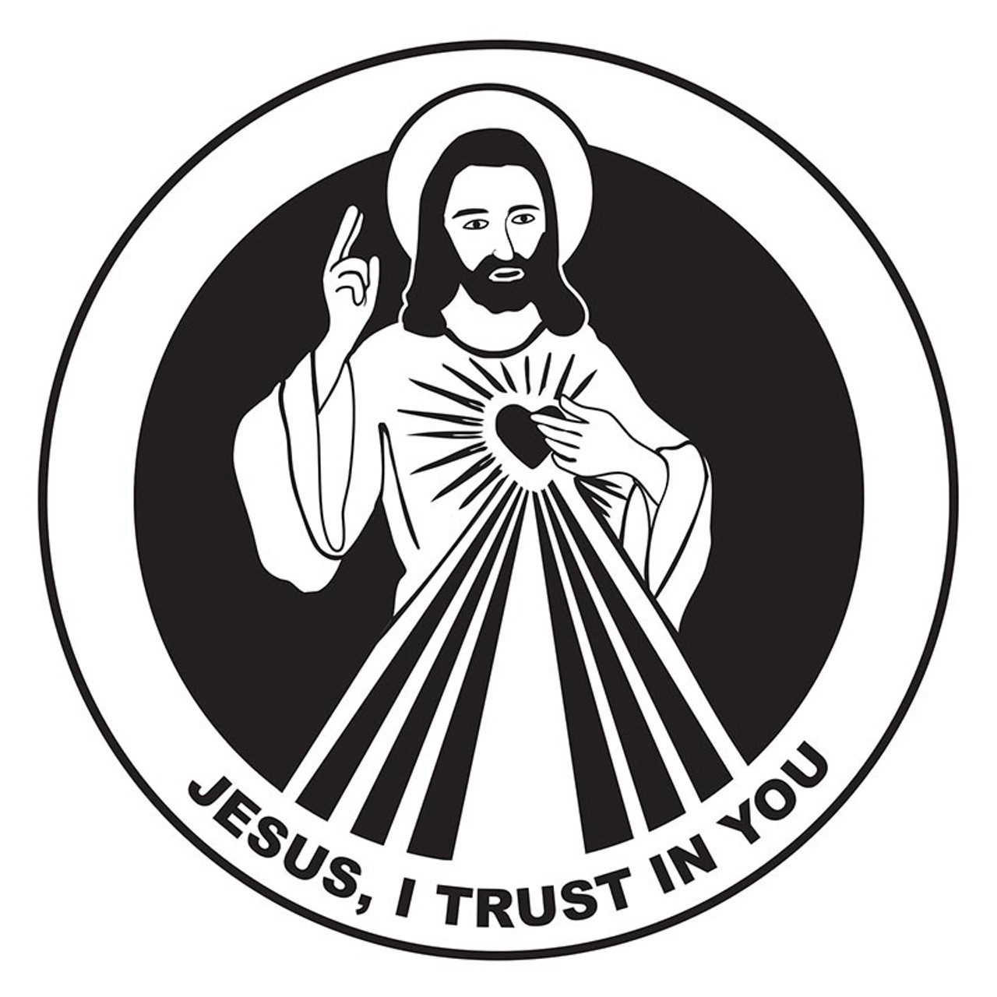
DIVINE MERCY SUNDAY is the Octave Day of Easter, a day that celebrates the merciful love of God shining through the Easter Triduum and the whole Easter mystery. It is a day of declaration of reparation for all sin. Our annual celebration will begin on Sunday, April 7, with Confessions at 2:00 P.M. (several priests will be available) followed by the Holy Hour of Mercy at 3:00 P.M.
Our Lord told St. Faustina: “On Divine Mercy Sunday, the very depth of My tender Mercies are open. I pour out a whole ocean of graces upon souls who approach the fount of My mercy. The soul that will go to Confession and receive Holy Communion shall obtain complete forgiveness of sin and punishment.”

WEEKLY PARISH EVENTS CALENDAR
Monday, April 1
11:00 A.M. Catholic Daughters (MR)
Tuesday, April 2
6:00 A.M. That Man Is You (DPC)
Friday, April 5
7:00 A.M. Adoration (Church)
Saturday, April 6
3:00 P.M. Confessions (Church)
Sunday, April 7 DIVINE MERCY SUNDAY
9:00 A.M. Adult Contemporary Choir (Music Rm.)
10:00 A.M. First Sunday Coffee and Donuts (MR)
2:00 P.M. Divine Mercy Confessions (Church)
2:30 P.M. Teen ACTS (DPC)
3:00 P.M. Divine Mercy Service (Church)
6:30 P.M. High School Youth (DPC)

OLPS PARISH SUPPERS: WILL RESUME IN SEPTEMBER. THANK YOU KNIGHTS OF COLUMBUS COUNCIL 8029!!

ANNUAL DIOCESAN APPEAL: The Diocese of Alexandria begins its 2024 Annual Diocesan Appeal, with the theme “God’s Gift, Our Response.” This an opportunity for us to unite with all Catholics in our Diocese and the universal church to share our blessings and to show our concern for one another. The ADA lets us act together as a family and to support programs and services no single individual or parish can offer alone. Your gift is very important, and is vital to the success of the Appeal. Every registered household in the Diocese will receive a letter and brochure from Bishop Marshall.
Our Parish Goal for this year’s A.D.A. is $95,642.00. Please take time to prayerfully consider what you will give in support of our Diocesan Church. Thank You.

OLPS SCHOOL BULLDOG BYTES

EASTER HOLIDAYS: Prompt Succor School will be closed this week for Spring Break. We will resume classes on Monday, April 8.

OLPS CRAWFISH BOIL OFF: Please join us for our annual OLPS Crawfish Boil Off! The Crawfish Boil Off will be held Saturday, April 13, from 3:00 to 6:00 P.M. at The Randolph Riverfront Center. If you are interested in forming a team, purchasing a table or purchasing a ticket, please go to www.promptsuccor.org. We are looking forward to a great event!

ENROLLMENT: Enrollment for the 2024-2025 school year is now open. If you have questions regarding enrollment, please reach out to our office at 318-487-1862.

4TH ANNUAL ADAM JEANSONNE GOLF TOURNAMENT: Our Lady of Prompt Succor Church Youth Group is having their 4th annual Adam Jeansonne Memorial Golf Tournament at Links on the Bayou on Friday, April 12. Proceeds help fund summer camps. Tournament format is four-person scramble. Lunch and beverages included, great prizes, team entry fee is $400 or $125 a person. To register a team of four, go to https://www.eventbrite.com/e/4th-annual-adam-jeansonne-memorial-golf-tournament-tickets-793709696067?ref=eios or the church office. For more information, email or call Felicia Schneider at jrhigh@olpschurch.org or call (318) 445-9748, ext. 228.

MARRIAGE DAY OF REFLECTION
Will be hosted by OLPS Parish on Saturday, April 27, from 8:00 AM to 3:00 PM, beginning with Mass in church. Do you want to connect more with your spouse? Do you want some time for yourselves away from the chaos of daily life? Do you want to fight for God’s plan for your marriage? Join us for a day to engage in the spiritual battle and take a step forward in your journey as a couple. The day will include talks & powerful testimonies, praying together, Mass, Adoration, Reconciliation & meals. For more info., contact Chris & Jenay Franco at (504) 666-2019 or cnfranco@gmail.com.
Register here: https://bit.ly/marriageday2024
OLPS YOUTH

CCD: CCD meets on Wednesday evenings at the school from 6:30 to 7:30 P.M. during the school year. CCD serves Pre-K through 5th grade and OCIC. For more information, contact Blair Jeanise at blair.jeanise@olpschurch.org.

JUNIOR HIGH YOUTH: Our Junior High group (grades 6-8 from all schools) meets on Wednesdays from 6:00 to 7:30 P.M. in the DPC/Fr. Menard Room. For more information, contact Felicia Schneider at jrhigh@olpschurch.org.

SENIOR HIGH YOUTH: High school youth meet on Sundays after 5:30 P.M. Mass in the Divine Providence Youth Center during the school year. For more information, contact Kevin Malone at kevin.malone@olpschurch.org.

CONFIRMATION: Confirmation is for 11th grade students. For more information, contact the church Office or Kevin Malone, Confirmation Coordinator, at 729-2017 or kevin.malone@olpschurch.org.

WOMEN’S SILENT RETREAT: “Seeking Grace” Women’s Silent Ignation Retreat will be held at Maryhill Renewal Center from April 26-28. Author, speaker, spiritual director and retreat facilitator, Becky Eldridge, will guide this women’s preached retreat. The deadline to register is April 19. The cost is $225 per person. A $100 deposit in the form of a check is required. To register, visit www.diocesealex.org.

AUTOMATIC GIVING: Online Giving is a convenient option to continue to support OLPS Church and its mission. Your vital support can still happen regardless of where you are. See this week’s “Look What’s Happening” Flocknote or email julie.bayone@olpschurch.org for more information.

VIRTUS TRAINING will be held Tuesday, April 23 at 6:00 P.M. at the St. Joseph Catholic Center. To register, go to www.virtus.org. All adult volunteers with youth-related ministry are asked to keep up with their monthly Virtus Bulletins, the Recertification modules & 5-year background checks, in order to continue as a volunteer in these areas of ministry. Thank You.

LECTORS FOR APRIL 6-7
4:00 PM Paul Mathews and Jamie Perotti
7:00 AM Pam Vickery
9:00 AM Lector needed and Susan Abbott
10:30 AM Miranda Morley and Lisa Campo
5:30 PM Jeff Zeringue and Derek Descant
OUR LADY OF PROMPT SUCCOR
Church Office/Rectory Telephone: 445-3693
Youth Center Telephone: 445-9748, ext. 229
Fr. Rusty Rabalais, Pastor
Fr. Thomas Kennedy, Parochial Vicar
Fr. David Braquet, Part-time Ministry
Fr. Joy Antony, In Residence
Rev. Mr. Mike Young & Rev. Mr. Les Glankler, Deacons
Julie Bayone, Parish Manager
Renea Ducote, Bookkeeper / Margaret Shiver, Receptionist
Megan Beck, Principal of OLPS School
Dr. Thomas Robichaux, Jr., Director of Music Ministry
Grae McCullough, Associate Director of Music Ministry
Kelly Pease Lombardi, Music Minister
Jordan LaCour, Coordinator of Programs
Kevin Malone, Coordinator of Sr. High Youth
Felicia Schneider, Coordinator of Jr. High Youth
Blair Jeanise, Coordinator of CCD & OCIC
Steve Gauthier, Coordinator of OCIA
Toni Ihle, Coordinator of Church Nursery
Matt Bruyninckx, Finance Council Chair & Chad Gremillion, Pastoral Council Chair
Chad Soprano, School Council Chair
SACRAMENTS/LITURGY/DEVOTIONS
Mass: Saturday 4 PM
Sunday 7, 9 & 10:30 AM; 5:30 PM
Weekdays: 6:30 AM & 5:30 PM
Saturday: 8:00 AM
Holy Day of Obligation: Vigil - 5:30 PM
Holy Day: 6:30 AM; 12:05 P.M. & 5:30 PM
Sacrament of Penance: Saturdays 3:00 - 3:50 PM; Sundays 5:00 – 5:25 PM
and Weekdays before Mass
Sacrament of Baptism: Baptismal Preparation Class by appointment.
Register in advance by calling the Church Office (445-3693).
Baptisms are ministered by appointment.
Sacrament of Holy Eucharist: For the sick and homebound.
Contact Jordan LaCour at the church office, 445-3693.
Anointing of the Sick: Please contact our Parish Priests at 445-3693.
Adoration of the Blessed Sacrament: The Blessed Sacrament is exposed
from 9:00 AM - 5:00 PM every Friday in the Church.
RELIGIOUS FORMATION PROGRAMS
CCD – During the School Year
Junior & Sr. High Youth – Wednesday & Sunday evenings during the School year



READINGS FOR MARCH 31
Acts 10:34a, 37-43; Ps. 118; Colossians 3:1-4; John 20:1-9

IN MEMORY:
Please pray for the repose of the souls of all our parishioners who have recently died, and for the consolation of their families.

PLEASE PRAY FOR THE SICK: Charlotte Allen; Paul Alonzo; John Andries; Diane Ardoin; Bridget Ardoin; Roman Armstrong; John ‘Lad’ Baker; Debra Baker; Jack Bender; Cilton Bordelon; Doris Bordelon; Laura Maupin Bounds; Rose Brodnax; Shirley Brouillette; Dawn Brumfield; Jane Chaney; Egedio Cicardo; Alfred Cook, III; Clara Crooks; John Curley; Sandra Daniel; Reggie Dauzat; `Judy Deason; Norris Ducote; Cecile Ducote: Edith Dufour; Robert Duggan; Buddy Falkner; Connie Fiorenza; Mike Flynn; Jana Fontenot; Johnny Foster; Ripp Francis; John Gagnard; Pam Guillory: Robert Haines; Brandi Hare: Susan Harrison; Alfred Hempen; Stephanie Howard; Jesse Johnson; Bea Jones; Andy Juneau; John Kinder; Jimmy Lachney; Mary Laird; Angel LaJaunie; Betsy Lanclos; Tracy Lawrence; Abby Lee; Michael Lee; Shirley Leonard; Peter Lomonte; Sarah Lomonte; Marshall Matthews; Carley McGinty; Elaine Michiels; Jimmy Normand; Lee Odom; Caroline Pearson; Angela Pitts; Andrew Poe; Richard Powell; John Reynolds; Johnathan Rhea; Georgiana Robinson; Wendy Roy; Steven Ryland; Sam Sansing; Jerry Searcy; E. C. Smith; Noelle Soileau: Riley Stanley; Eloise Thiels; Theresa Thornhill; John Upton; Andy Vanderlick; Susan West; Virginia Whittington; Jackie Witcher; Joel Wood, and all the homebound of our parish community.
MASSES OF THE WEEK
SUN., MARCH 31: EASTER SUNDAY
7:00 A.M. Priests Intentions
9:00 A.M. Priests Intentions
10:30 A.M. Priests Intentions
5:30 P.M. Priests Intentions
MON., APRIL 1:
6:30 A.M. Alex Ekermeyer, Sandra Marien and
Joseph Marien, Jr.
5:30 P.M. Cheryl Arbour
TUES., APRIL 2:
6:30 A.M. Tandy Lane Rodgers and James Donald Feucht
5:30 P.M. Harvey Gonsoulin
WED., APRIL 3:
6:30 A.M. Charles L. Carbo, Sr.
5:30 P.M. Clyde Buddy Buford
THURS., APRIL 4:
6:30 A.M. Dr. Leonardo Amigo
5:30 P.M. Deceased members of the Voltz and Hooe
Families
FRI., APRIL 5:
6:30 A.M. Holly Morris Ihle
5:30 P.M. John Jeanise, Sr.
SAT., APRIL 6:
8:00 A.M. Dr. Bernardita Amigo
4:00 P.M. Holly Morris and Intention of B. Joubert; John
Cangelosi, Jr.; Marie A. “Molla” Carey; Frank
and Frances Constantino; Intention of Daniel
Garcia; Stephen Henthorne and Peggy St. John;
Charles Vanderlick (anniv.); Madelane Bender;
Diedre Miller; Intention of Tim Ledet, Sr.; Roy
Derbonne; Chase Michiels; Mike Villard, Jr.;
Mary Williams; Intention of Mary Lofton;
Egidio John DiStefano
SUN., APRIL 7:
7:00 A.M. John Bullion
9:00 A.M. Living and deceased members of the Gueringer
and Gagnard Families; Thelma Lee Norton; Al
Beach and deceased members of the Verzwyvelt
and Beach Families; Joseph Ray (anniv.); Emily
Biggs Carbo; Dave and Irene Dufour; David and
Charles David Ezernack; Frank Cicero;Intention
of Deacon Bill Aldridge; Sharon Hernandez and
Paul Hernandez; Bob and Jim Foster
10:30 A.M. John Jeanise, Sr.
5:30 P.M. Our Parish Family

GIFTS REPORT – CHURCH SUPPORT

Income needed for Mar. (five Sun.’s) | $122,250.00
Gifts on previous weekends in Mar. | $88,299.00
Gifts given last weekend | $16,956.00
Amount needed for Mar. | $16,995.00

THANK YOU FOR YOUR SUPPORT
OF OUR PARISH !

